Canadian 4th Armored Division 40
MILITARY

1ST CAN
AIR POWER
N/A

RESOURCES
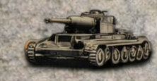
1 x Kampfgruppe
*Deploy to map or Strategic Reserve for 1 action

ORDERS: 3 Actions
-2 Attack Strength 1st CAN
+1 DRM Transport
The Canadian 4th Armored Division was severely hampered in its advance on Trun by the lethargy and incompetence of its commander, Major General George Kitching who was relieved of command on August 21st. Unofficially he was effectiveley superceded by corps HQ on August 18th.

